**Manual for AlphaTims’ graphical user interface**

Developed by: *Eugenia Voytik, Sander Willems and Matthias Mann*.

This step-by-step manual is intended for the stand-alone graphical user interface (GUI) of AlphaTims. It will guide you through its installation procedure and usage.

Table of contents

[About - 1 -](#_Toc67323386)

[Installation - 2 -](#_Toc67323387)

[Windows - 2 -](#_Toc67323388)

[MacOS - 6 -](#_Toc67323389)

[Linux - 9 -](#_Toc67323390)

[How to use AlphaTims - 10 -](#_Toc67323391)

[Importing the data - 10 -](#_Toc67323392)

[Visualizing the data - 11 -](#_Toc67323393)

[Selecting data slices - 14 -](#_Toc67323394)

# About



[AlphaTims](https://github.com/MannLabs/alphatims) is an open-source Python package that provides fast accession and visualization of unprocessed LC-TIMS-Q-TOF data from [Bruker’s timsTOF Pro instruments](https://www.bruker.com/en/products-and-solutions/mass-spectrometry/timstof/timstof-pro.html). It indexes the data such that it can easily be sliced along all five dimensions: LC, TIMS, QUADRUPOLE, TOF and DETECTOR. It was developed by the [Mann Labs at the Max Planck Institute of Biochemistry](https://www.biochem.mpg.de/mann) and is available as a freely available open-source tool with an [Apache Licence](https://github.com/MannLabs/alphatims/blob/develop/LICENSE.txt) and [third-party licences](https://github.com/MannLabs/alphatims/blob/develop/LICENSE-THIRD-PARTY.txt).

# Installation



AlphaTims can be installed and used on all major operating systems (Windows, MacOS and Linux). Besides the GUI presented in this manual, AlphaTims can also be used as a command-line-interface and as a Python package. If high performance is required, we recommend to use the GUI that comes with the Python package instead of the stand-alone GUI. More details are available on the [GitHub repository](https://github.com/MannLabs/alphatims).

**IMPORTANT WARNING!** While AlphaTims is mostly platform independent, some calibration functions require Bruker libraries which are only available on Windows and Linux.

## Windows

For Windows, an installer for AlphaTims is provided as a single executable. The following steps will walk you through this installer. Note that AlphaTims can easily be uninstalled at any time and that older versions of AlphaTims do not need to be uninstalled before installing a new version.

1. Download [the latest release](https://github.com/MannLabs/alphatims/releases) for Windows (alphatims\_installer\_windows.exe) from the GitHub repository and open the .exe file. If a “Windows protected your PC” windows pops up, you can press “More info” to enable the option “Run anyway”.

****

1. In the appeared “Select Setup Install Mode” dialog we suggest to select “Install for me only (recommended)” option.

****

**IMPORTANT WARNING**! If you install AlphaTims for all users, you might need administrator privileges to run it each time on your computer (right-click on the AlphaTims logo on your desktop and select "Run as administrator").

1. In the appearing “Setup – AlphaTims version X.X.X” dialog window, accept the [License Agreement](https://github.com/MannLabs/alphatims/blob/master/LICENSE.txt) (note that additional [third-party licences](https://github.com/MannLabs/alphatims/blob/develop/LICENSE-THIRD-PARTY.txt) are also applicable) and press the “Next” button.

****

1. Select the destination location for the installation for AlphaTims and press the “Next” button.

****

1. In the next dialog window, you have the option to create a desktop shortcut. If desired, mark the “Create a desktop shortcut” check box. Finally, press the “Next” button.

****

1. Check the setting and if everything is correct, press “Install” button. You may go back to change some settings using the “Back” button or “Cancel” the installation.

****

1. The installation process is indicated by the progress bar. Wait until the installation process is finished, this might take a few minutes. It is advised to directly test if the installation was successful by marking the “Launch AlphaTims” check box before pressing the “Finish” button.
2. If a dialog window appears with “Windows Security Alert”, press the “Allow access” button that will prevent the Windows Defender Firewall from blocking AlphaTims.
3. After launching AlphaTims, a terminal showing background information on AlphaTims should open, as well as a new tab in your default browser with the URL “http://localhost:XXXXX”. Note that this URL can be copy-pasted to other browsers as well and that no internet connection is required since you run AlphaTims on your local machine. For optimal performance, we recommend to use Google Chrome or Mozilla Firefox.

## MacOS

For MacOS, an installer package is provided to install AlphaTims. After installation, a self-contained application will be added to your “Applications” folder that can completely be uninstalled by moving it to the Bin.

**IMPORANT WARNING!** While AlphaTims is mostly platform independent, some calibration functions require Bruker libraries which are only available on Windows and Linux. This issue can be circumvented by converting Bruker .d folders to .hdf files (see below) on Windows or Linux, and then use these .hdf files instead of .d folders on MacOS.

1. Download [the latest release](https://github.com/MannLabs/alphatims/releases) for macOS (alphatims.app.zip) from the [GitHub repository](https://github.com/MannLabs/alphatims) and run the .pkg package. If it gives the message that it cannot be opened because it is from an unidentified developer, you can close this message by pressing the “OK” button before going to Apple’s “System Preferences” menu and allow it in the section “Security & Privacy” under the “General” tab

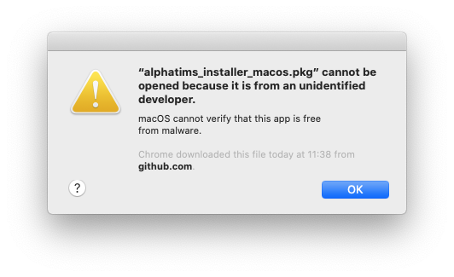**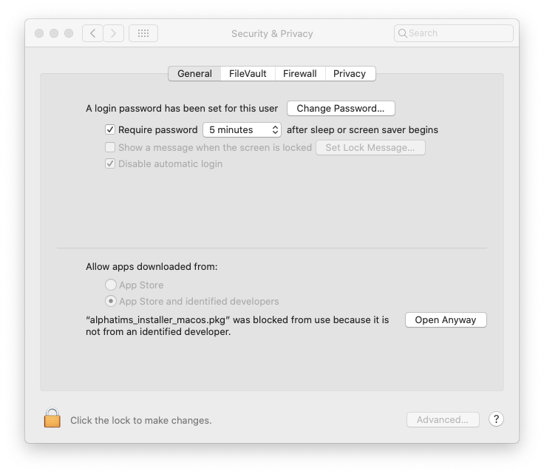**

**IMPORTANT WARNING!** You must always remove old versions of AlphaTims before installing a new one in MacOS. You can do this simply by dragging “AlphaTims.app” from the “Applications” folder to the “Bin”.

1. After launching the installer, you will get a brief introduction screen with a link to this manual. Click “Continue”.

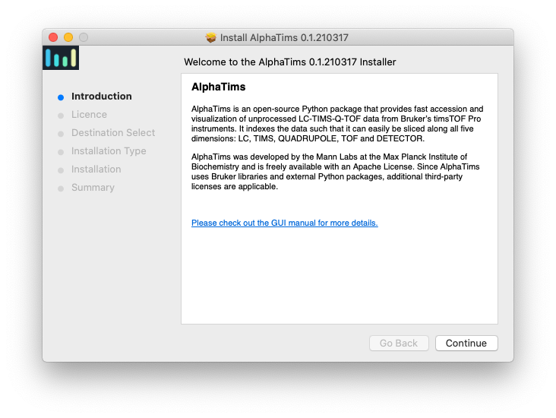

1. Next, you will be presented with with the [License Agreement](https://github.com/MannLabs/alphatims/blob/master/LICENSE.txt) (note that additional [third-party licences](https://github.com/MannLabs/alphatims/blob/develop/LICENSE-THIRD-PARTY.txt) are also applicable). After pressing the “Continue” button, a pop-up will appear where you can specify that you agree with the license.

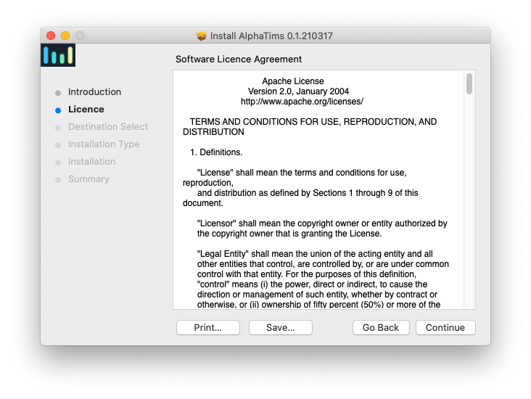

1. AlphaTims is always installed in your “Applications” folder for all users. Start the installation by clicking the “Install” button. A pop-up will appear asking you for your password.

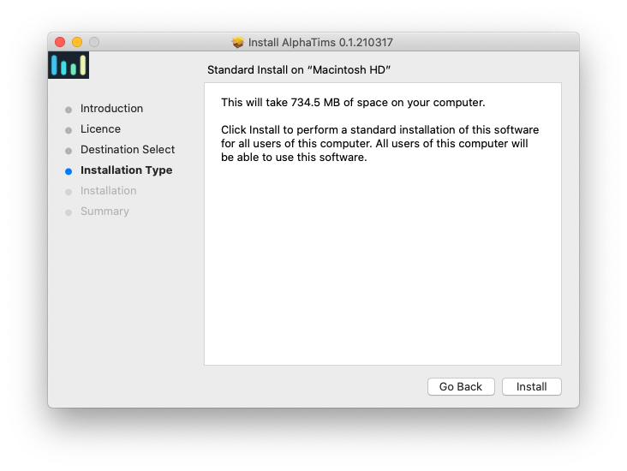

1. You will get a message once AlphaTims is successfully installed. We advise you to test out if the installation was successful by launching AlphaTims (from the “Applications” folder, though the “Launchpad” or with a “Spotlight search (cmd + space)”. Note that the first time launching AlphaTims can be relatively slow. This should be faster for subsequent use.

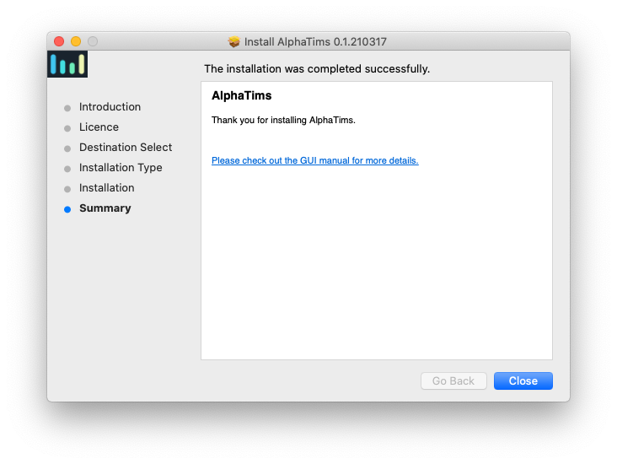

1. After launching AlphaTims, a terminal showing background information on AlphaTims should open, as well as a new tab in your default browser with the URL “http://localhost:XXXXX”. Note that this URL can be copy-pasted to other browsers as well and that no internet connection is required since you run AlphaTims on your local machine. For optimal performance, we recommend to use Google Chrome or Mozilla Firefox.

**TROUBLESHOOTING:**

* You can either deny or ignore the popup message “Do you want the application “python3.8” to accept incoming network connections?”, since AlphaTims does not use an internet connection.
* If nothing happens when you launch AlphaTims, you might need to grant it permissions by going to the macOS menu "System Preferences | Security & Privacy | General".
* If AlphaTims still does not open after the previous step, it is possible that macOS already quarantined the AlphaTims application. In this case, open a terminal and navigate to the applications folder in the terminal (with a “cd” command or by drag-and-dropping the applications folder). Now remove AlphaTims from quarantine by running the command <*xattr -dr com.apple.quarantine AlphaTims.app*> (copy everything between <>).

## Linux

For Linux, AlphaTims can be installed as a Debian package. **Note that by using AlphaTims, you accept the terms of the** [**Apache Licence**](https://github.com/MannLabs/alphatims/blob/develop/LICENSE.txt) **and** [**third-party licences**](https://github.com/MannLabs/alphatims/blob/develop/LICENSE-THIRD-PARTY.txt)**!**

1. Download [the latest release](https://github.com/MannLabs/alphatims/releases) for Linux (alphatims\_installer\_linux) from the GitHub repository.
2. Run the installer either by double clicking it, or by executing the command <*sudo dpkg -i alphatims\_installer\_linux.deb*> (copy everything between <>).

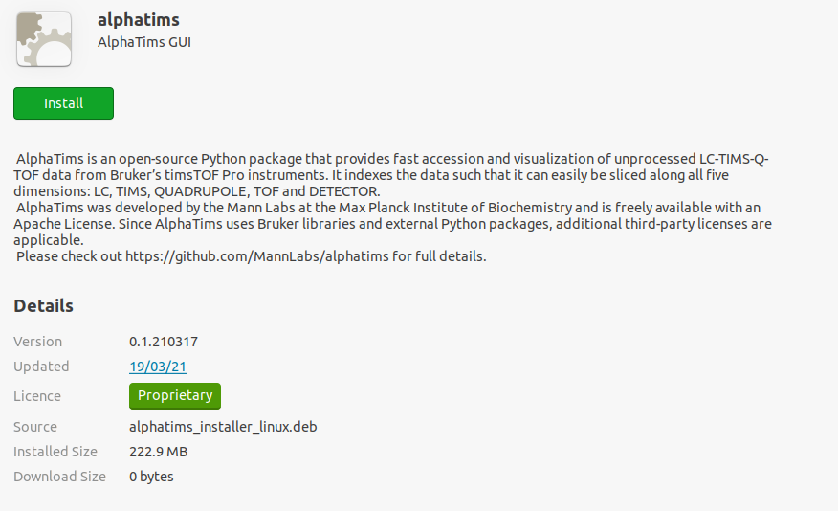

1. After launching AlphaTims, a terminal showing background information on AlphaTims should open, as well as a new tab in your default browser with the URL “http://localhost:XXXXX”. Note that this URL can be copy-pasted to other browsers as well and that no internet connection is required since you run AlphaTims on your local machine. For optimal performance, we recommend to use Google Chrome or Mozilla Firefox.

# How to use AlphaTims



After launching AlphaTims, a terminal showing background information on AlphaTims should open, as well as a new tab in your default browser with the URL “http://localhost:XXXXX”. Note that this URL can be copy-pasted to other browsers as well and that no internet connection is required since you run AlphaTims on your local machine. For optimal performance, we recommend to use Google Chrome or Mozilla Firefox.

## Importing the data

The first step for AlphaTims, is to upload a dataset. Before you do so, it is always a good idea to check out some of the data manually. A lot of information is present in the “analysis.tdf” file in the original .d folder with e.g. [DB Browser for SQLite](https://sqlitebrowser.org). In case you have already used AlphaTims to create an .hdf file (see below), you can investigate this data with e.g. [HDF compass](https://support.hdfgroup.org/projects/compass) or [HDFView](https://www.hdfgroup.org/downloads/hdfview/). In both cases, there is a lot of global metadata available, as well as information about frames and precursors.

**IMPORTANT WARNING!** Required RAM usage for a dataset is roughly twice the size of a .d folder!



* In the “Specify an experimental file:” box, you can provide the filepath to a .d folder with raw Bruker data. Alternatively, a path to an .hdf file that was previously generated with AlphaTims (see below) can also be provided. In case of the latter, it is strongly advised to use the same version of AlphaTims to avoid incompatibilities. File paths can easily be copied to the clipboard by “shift key + right mouse” (Windows), “option + command + c” (MacOS) or “ctrl + c” (Linux). **Note that the copied path should not contain quotes at the beginning or end and that this a local path, i.e. not on a mounted drive.**
* Press the "Upload Data" button. The loading process is indicated by a spinner symbol. A rough estimate on loading times can be found on the [performance section of GitHub](https://github.com/MannLabs/alphatims#performance). Alternatively, a terminal is opened in the background on Windows and Linux that also shows the progress of data loading (note that some additional time is required for the visualization itself). **Always wait until the spinner completes before continuing.**
* AlphaTims can be closed by pressing the “Quit” button or by closing all browser tabs that run AlphaTims. In rare cases, AlphaTims keeps running in the background. On Windows and MacOS this is evident by the background terminal that is not closed automatically. If this is the case, terminate AlphaTims by pressing “ctrl + c” in the terminal.
* If something went wrong or if a specified file does not have a .d or .hdf extension, an error message is displayed.

**TROUBLESHOOTING:**

* If you need help, the button “GUI manual” will download this manual. If you cannot find an answer here, you can [open an issue on GitHub](https://github.com/MannLabs/alphatims/issues).
* Some sample files are available on the [test data section of GitHub](https://github.com/MannLabs/alphatims#test-data).

## Visualizing the data

Once your data has been loaded into RAM, a few new panels have become available in your browser. On the left, there is panel to control all parameters. On the right, there are the following three plots that allow you to visually explore your data:

1. **Total Ion Chromatogram**

A line plot displaying the total ion chromatogram (TIC) of all the unfragmented frames in the complete run.

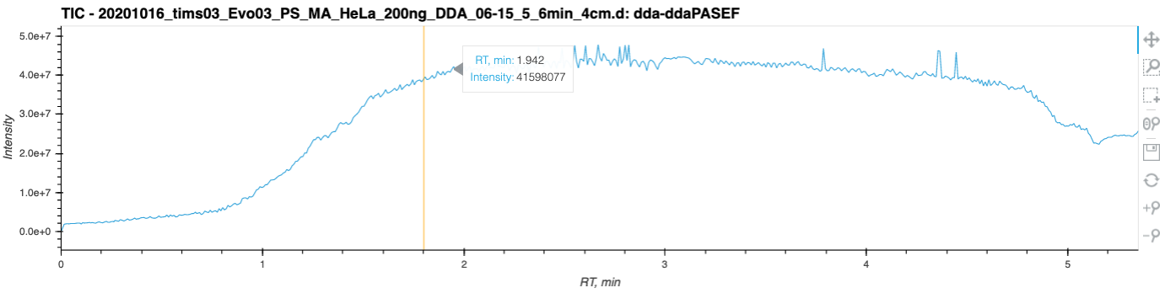

* + The currently selected retention time (RT) slice is highlighted in orange. This can be changed in the “Parameters” panel on the left (see below).
  + If you hover over the chromatogram, all annotation information for the position of the cursor will be displayed. Here, this is the exact RT in minutes and its intensity value.
  + For each plot, there are some tools available to interact with it, such as zooming in or saving the plot. A brief description of these tools is available at the end of this section.

1. **Heatmap**

A heatmap of the intensity values of the currently selected data. Both the x-axis and y-axis can be changed to "m/z, Th", "RT, min" or "inversed IM, V·s·cm-2". This plot is generated with the use of [Datashader](https://datashader.org/) Python library that allows to “rasterize” or “aggregate” the huge amount of data points into regular grids based on some aggregator statistics functions. Here, this aggregator is the sum of all the intensity values per pixel. The most intense pixel is always colored “pure white” and the color of all other pixels that are visible is determined relative to this most intense pixel. When interactive tools such as zooming in/out are used, each plot will be rebuilt and recolored based on the currently visible selection.

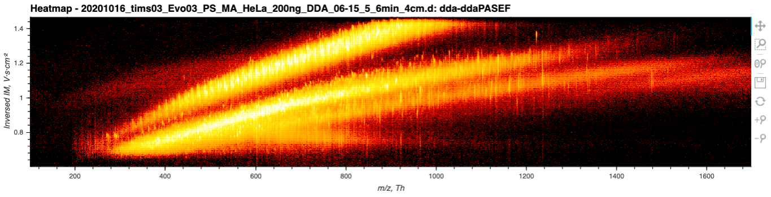

* A specific set of data points to visualize can be selected in the “Parameters” panel on the left (see below). In the “Parameters” panel you can also change the x-axis and y-axis.
* As for the TIC, there are a few different tools available to interact with the plot such as zooming in or saving the plot. A brief description of these tools is available at the end of this section.

1. **Spectrum / Extracted ion chromatogram / Mobilogram**

A line plot displaying the summed intensity values in function of the "m/z, Th", "RT, min" or "inversed IM, V·s·cm-2". Note that AlphaTims displays raw data and that spectra are thus never centroided.

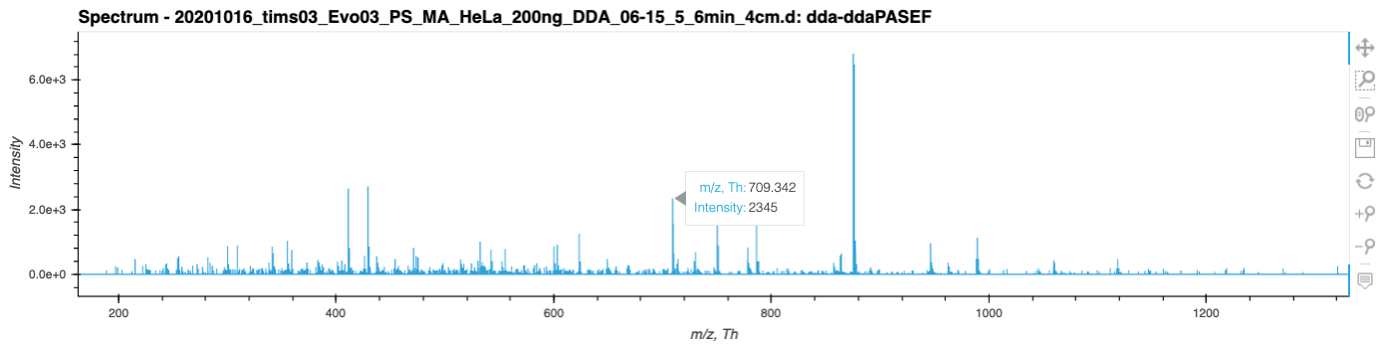

* If you hover over the plot, all annotation information for the position of the cursor will be displayed.
* A specific set of data points to visualize can be selected in the “Parameters” panel on the left (see below). In the “Parameters” panel you can also change the x-axis.
* A brief description of the tools to interact with this plot is available at the end of this section.

1. **Tools**

Each plot comes with a number of interactive tools:

* + pan_icon The *pan tool* allows to pan the plot by click-and-holding the left mouse button and dragging it.
  + box_zoom_icon The *box zoom tool* allows to select a rectangular region on which to zoom by selecting it with the left mouse button.
  + box_select_icon The *box select tool* is disabled for AlphaTims and has no effect.
  + wheel_zoom_icon The *wheel zoom tool* allows to zoom in and out by scrolling with the mouse scroll wheel. Note that the location of the mouse cursor defines where to scroll to. Alos not that of you scroll outside the plot area on one of the axis, you can zoom in or out in dimension instead of two.
  + The *save tool* allows you to save a PNG image of the plot.



* + reset_icon The *reset tool* restores the plot to its original values, i.e. the x-limits and y-limits are set to the minimum and maximum values of the selected data.
  + hover_icon The *hover tool* allows to hover over a given data point and display its associated information.
  + zoom_in_icon The *zoom-in tool* increases the zoom of the plot.
  + zoom_out_icon The *zoom-out tool* decreases the zoom level of the plot.

## Selecting data slices

On the “Parameters” panel in the left there are several cards that can be opened and collapsed to select specific datapoints and determine how you want to visualize or export.

1. **LC dimension: “Select rt\_values / frame\_indices” card**

With this card you can select which datapoints you want to select in the LC dimension. You can do this either by the RT values (in minutes) or by frame indices, which have a one-to-one relation.

**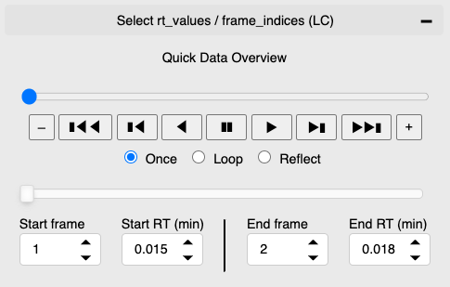**

* To get a quick overview of the uploaded dataset, you can use the “player” to automatically loop over different RT values. It selects ten MS1 frames which are distributed with the same interval through the whole gradient. The player has a button to go to the last (“ C:\Users\voytik\Downloads\next-track_icon-icons.com_70913.png ”) or the first (“ C:\Users\voytik\Downloads\next-track_icon-icons.com_70913.png ”) frame in the dataset, step forward to the next (“󠇯 C:\Users\voytik\Downloads\nexttrackbutton_113555.png ”) or backward to the previous (“ C:\Users\voytik\Downloads\nexttrackbutton_113555.png ”) frame. At any point, you can show new frames sequentially (one by one) in forward (“ ▶ ”) or a backward (“ ◀️ ”) order and pause the visualization (“Pause Button Transparent | PNG All”). It also provides control over the loop policy which determines whether to show the frames 'once', 'loop' through them, or 'reflect' the process. Finally, the “-” and “+” buttons slow down and speed up the player speed.

Note that the player resets the currently selected settings of the LC dimension (see below). The selection for all other dimensions (see below) remain valid and unchanged. Note furthermore that selecting and visualizing data always requires some time. As such, setting a high speed for the player with the “+” button will not allow enough time for the plots to be updated.

* With the slider you can select a range of RT values or frame indices. Note that these have a one-to-one relation. Selecting a start index 1 and end index 3 means you select all points *p* that satisfy $1≤p<3$, i.e. **the end value is not included**! Selecting exactly one index can thus be done by selecting e.g. start index 1 and end index 2. Note that an empty selection (end smaller than or equal to start) is not possible. You can also click on the left or right bar of the slider and decrease/increase indices by one with the left/right arrow key. If a large selection is made, the start and end can be shifted simultaneously by click-and-dragging somewhere between the start and end.
* Instead of dragging on the slider, you can also select the start frame index manually. Increasing or decreasing the index by one can also be done with small arrows at the right of this box. If you select an index that is equal to or higher than the currently selected end index the end index will automatically be set the start index +1 to ensure there is no empty selection. Note that this is an excellent manner to select single values instead of a range.
* Instead of selecting by frame index, you can also select the start of your selection by RT value (in minutes). Note that the small arrows in the right of this box also increase and decrease your RT value, but that the size of this increment/decrement is dependent on your dataset. Note that your entered value might be changed slightly, since only those values that exactly correspond to a frame index are valid.
* The end index can also be defined manually. As for the slider, note that the end index is not included in the selection! When an end index is selected that is equal to or smaller than the start index, the start index is automatically set to the end index -1.
* Similarly, you can select the end by RT value instead of by frame index.

1. **TIMS dimension: “Select mobility\_values / scan\_indices” card**

With this card you can select which datapoints you want to select in the TIMS dimension. You can do this either by the inversed mobility values (1/Ko) or by scan indices, which have a one-to-one relation. Note that inversed mobility values are in decreasing order, while scan indices are in ascending order. You can use it in exactly the same manner as the LC dimension, with the exception that there is no player option available.

1. **QUADRUPOLE dimension: “Select quad\_values / precursor\_indices” card**

With this card you can select which quadrupole (and indirectly collision cell) settings you want to use for your selection.

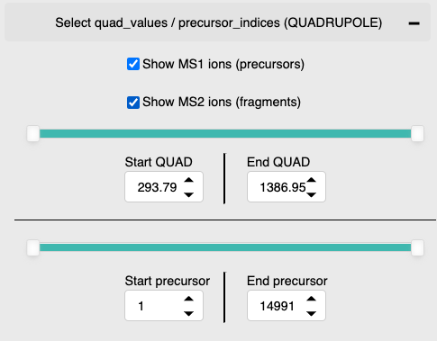

* To include precursor ions, mark the “Show MS1 ions (precursors)” check box.
* To include fragment ions, mark the “Show MS2 ions (fragments)” check box.

You may select both precursors and fragment ions at the same time. Note that it is impossible to distinguish between precursor and fragment ions in the plots.

* If fragment ions are included in the selection, the quadrupole m/z value option becomes available. You can select a range of m/z values with the slider. Alternatively, you can manually select specific m/z values by using the input fields “Start QUAD” and “End QUAD”. This slider and these field have no impact on precursor ion selection.

Note that only a partial overlap between the instrumental settings and the selected quadrupole settings is required. For example, imagine the instrument selected two precursors with m/z values 509.5 and 601.5. The first was selected by setting the quadrupole m/z range to 508.0 – 601.0 and the second by setting the quadrupole m/z range to 600.0 – 603.0. If AlphaTims is used to select the m/z range 600.9 - 601.2, all fragment ions from both precursors will be retained. In contrast to the other sliders and input fields, the start value and the end value of quadrupole m/z values can be equal without resulting in an empty selection. Still, setting a start value higher than an end value will automatically set the end value equal to the start value and vice versa.

* Instead of filtering fragments based on the quadrupole m/z values, you can also select them based on their precursor indices.

For data dependent acquisition (DDA), each precursor index corresponds to a single precursor selection of the quadrupole. Due to the Parallel Accumulation–Serial Fragmentation (PASEF) mechanism, a traditional MS2 spectrum is an aggregation of multiple mobility scans or even frames though. Note that a single precursor index in ddaPASEF thus always corresponds to an exact m/z value range selected with the quadrupole. While there is no strict one-to-one relation with the frame indices, larger precursor indices are generally found at larger RT values.

For data independent acquisition (DIA), a single precursor index refers to a window group. Such a window group is recurring frame, in which multiple “windows” can be defined by selecting different m/z values with the quadrupole. This means that there are as many precursor indices as the length of the cycle time (without the precursor frame), typically 1-16. The exact window layout and window groups can be found in the “DiaFrameMsMsWindows” table of the “analysis.tdf” file in the .d folder (you can open it with e.g. [DB Browser for SQLite](https://sqlitebrowser.org)). In contrast to ddaPASEF, it is very sensible to use combinations of precursors indices and quadrupole m/z values for diaPASEF.

A range of precursor indices can be selected with the slider. Alternatively, the input fields can be used to manually define the start and index. Note that empty ranges are not allowed and that setting a start index larger than an end index automatically adjust the end index to the start index +1. When an end index is selected that is equal to or smaller than the start index, the start index is automatically set to the end index -1. As this results in selecting exactly one precursor index, this is an excellent way to select traditional MS2 spectra one-by-one for visualization.

1. **TOF dimension: “Select mz\_values / tof\_indices” card**

With this card you can select which datapoints you want to select in the TOF dimension. You can do this either by the time-of-flight values or by TOF indices, which have a one-to-one relation (which is not linear but quadratic). Note that the TOF tube is independent of the quadrupole and does not allow to distinguish between fragment and precursor ions, which behave identical once they have passed the collision cell. You can use this card in exactly the same manner as the LC dimension, with the exception that there is no player option available.

1. **DETECTOR dimension: “Select intensity\_values” card**

With this card you can select which datapoints you want to select in the DETECTOR dimension. You can use it in exactly the same manner as the LC dimension, with the exception that there is no player option available and that there are only intensity values and no indices.

1. **“Select axis for plots” card**

This card allows to change the axis for the heatmap or to change between a spectrum, extracted ion chromatogram (XIC) or Mobilogram.

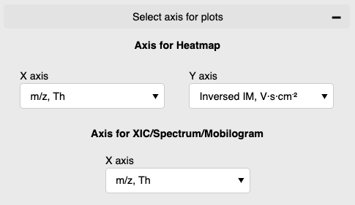

1. **“Export data” card**

This card allows to export all the data or a selection hereof in different formats.

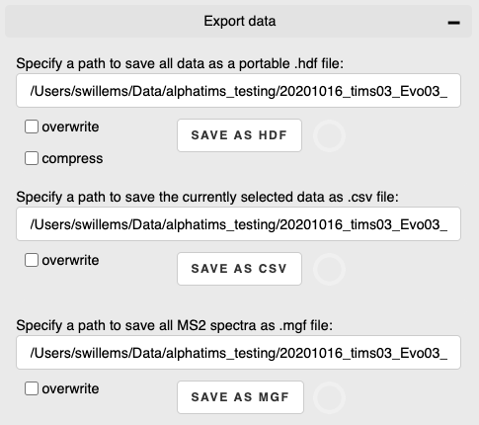

* + **HDF format**

AlphaTims uses several indices to provide a fast selection of unprocessed data in all dimensions. To avoid recalculating these indices when loading a dataset, a complete dataset can be exported as an [HDF file](https://www.hdfgroup.org/solutions/hdf5/). Loading raw data from an HDF file is typically two or three times faster than loading from a .d folder. Perhaps more importantly, this HDF file is portable between different operating systems. Since there are no Bruker libraries available on MacOS to calibrate the data, *it is good practice (but not required) to create HDF files on Windows or Linux and copy-paste these HDF files to MacOS*.

By default an HDF file will be saved in the same directory as the .d folder with the same file name and an .hdf extension. You can manually set any other local path that is not on a mounted drive. To avoid accidental data deletion or corruption, the “overwrite” check box is not checked by default. Once you press the "SAVE AS HDF" button, the spinner symbol is activated. In general saving to HDF files is very fast, as shown on the [performance section of the GitHub repository](https://github.com/MannLabs/alphatims#performance). Once the file is successfully saved, a message will appear and the spinner will deactivate. They can easily be inspected by e.g. [HDF compass](https://support.hdfgroup.org/projects/compass) or [HDFView](https://www.hdfgroup.org/downloads/hdfview/).

HDF files are roughly twice the size of .d folders. However, they can be compressed if space is an issue or if the file needs to be transferred to e.g. MacOS. Compressed HDF files are only slightly larger than .d folders, but saving and loading them is often three to six times slower than saving or loading uncompressed HDF files.

* **CSV format**

To enable downstream analysis, the currently selected data can be downloaded to a .csv file. The columns of this .csv file contain the coordinates of all dimensions:

* + 1. raw\_indices
    2. frame\_indices
    3. scan\_indices
    4. precursor\_indices (precursor ions have the index 0)
    5. tof\_indices
    6. rt\_values
    7. mobility\_values
    8. quad\_low\_mz\_values (precursor ions have the value -1)
    9. quad\_high\_mz\_values (precursor ions have the value -1)
    10. mz\_values
    11. intensity\_values

By default a .csv file will be saved in the same directory as the .d folder with the same file name and an \_data\_slice.csv extension. You can manually set any other local path that is not on a mounted drive. To avoid accidental data deletion or corruption, the “overwrite” check box is not checked by default. Once you press the "SAVE AS CSV" button, the spinner symbol is activated. Once the file is successfully saved, a message will appear and the spinner will deactivate.

* + **MGF format**

AlphaTims does not provide any identification. Since not all tools can work with .d folders, you can download all MS2 spectra in MGF format. This is done completely similar to downloading a .csv file. Since MGF files are not binary, this can be relatively slow. On Windows and Linux, you can track the progress in the background terminal

1. **“Undo | Redo” buttons and “Strike count (limit / current estimate)” option**

It is possible to undo and redo any change in your selection. Note that this does not apply to exporting, strike count estimation, image zooming or (re)loading other datasets. You can also revert multiple actions by clicking the “redo” or “undo” button multiple times. Take into account that reverting is not instantaneous and that it could take some time to update the widgets values and the plots.

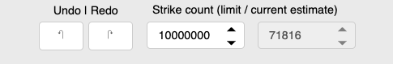

While AlphaTims is intended to be fast, selecting many points can be very slow under certain circumstances. To avoid AlphaTims crashing when this does happen, we estimate how many detector strike counts, i.e. data points, will be selected with the current selection before actually retrieving them. This is a very crude estimate that assumes all detector strikes are homogeneously distributed in the LC, TIMS, QUADRUPOLE and TOF dimension. If this estimate is larger than a preset limit (by default ten million), no data is selected at all and nothing will be plotted. This limit can manually be set to any value the user chooses. Note that changes in the strike count limit cannot be reverted with the “redo” and “undo” button and do not immediately trigger an update of the selected data without changing the selection.

**IMPORTANT WARNING!** We advise you to use extreme cation when increasing the strike count limit, as this can result in long loading times and large RAM usage which can crash not only AlphaTims but your whole operating system!